Masters in Data Science

Academic Year: (2021/2022)

Final project by:

l. EHIzojie
J. aluko
M. egbo
L. ABDULMUMIN

GLOBAL ECONOMIC IMPACT OF COVID-19: NIGERIA IN PERSPECTIVE

Rome

September, 2022

DECLARATION
We hereby declare that this is our original work and was done under appropriate supervision, and that it has not been submitted anywhere else, in parts or whole, for any other purpose.

CERTIFICATION
This is to certify that this capstone project was supervised by Mr. Solomon Adebayo and that it is the original work of the candidates named above.

ACKNOWLEDGEMENT
We wish to first and foremost acknowledge the Almighty God who in His infinite mercy gave us the grace, wisdom and strength to sail through this vigorous but interesting training up to this stage.
We appreciate our families and friends whom through their tireless supports and encouragements were the backbone of our academic struggles, without whom, this would not have been possible.
Our many thanks goes to the project supervisor, Mr. Solomon Adebayo for his professionalism, gentle advice, guidance, diligence, support and encouragement throughout the duration of this project. His contributions are invaluable to the success of this work. Our thanks also go to the Didactic team and all the Faculties of Rome Business School Nigeria Campus, who impacted the knowledge, which were very essential in the execution of this work.
Finally, to the Nigerian Bureau of Statistic who provided us with the needed data in this study we say, thank you.

EXECUTIVE SUMMARY

Background:

Methodology

Result

Conclusion

Table of Contents
Cover page 1
Declaration 2
Certification 3
Acknowledgement 4
Executive Summary 5
Table of contents 6
Chapter One 7
Chapter Two 12
Chapter Three 31
Chapter Four 38
Chapter Five 54
References 61

CHAPTER ONE

- BACKGROUND OF THE STUDY
The world faced an unexpected recession due to the disruption of the COVID-19 pandemic in the global economy. Due to its rapid propagation, a proper evaluation of the economic impacts of COVID-19 crisis is not only desirable but challenging if the aim is to mitigate uncertainty. The COVID-19 crisis has its origins in the policy measures adopted to combat the health crisis, while the 2008–2009 crisis had economic roots contingent on financially related issues. At the current time, the collapse of international trade has been driven by the voluntary and mandatory confinement measures imposed on world trade. We aim to analyze the impact of said confinement measures on trade. Estimating COVID-19 impacts on trade would shed light on the cost of confinement measures and the evolution and forecast of bilateral trades.
Since the appearance of COVID-19 in Nigeria on 27th February 2020, the Nigerian economy seemed to have been plunged into turbulence. Thirteen days after its importation from Italy, precisely March 11, the World Health Organization (WHO) declared COVID-19 a global pandemic. As the spread of the virus continued internationally and locally at an unprecedented scale, the official responses appeared to limit it focal point on limiting the spread within the country through social isolation policies, which included shutting educational institutions, limiting work and restricting movement of people, providing palliatives to the “vulnerable and poorest of the poor”, imposition of night time curfews, and so on. Many observers believed that as much as the virus kept spreading, assessment of the depth and the breadth of the impact of the pandemic on the social and economic life of a nation was going to be difficult, if not impossible, until the situation returns to normal. But, what is the aftermath effect? This uncertainty is pervasive and has created a strong sense of foreboding among the general public, researchers and policy makers.
It is estimated that during the lockdown periods, Nigeria’s GDP suffered a 34.1 percent loss due to COVID-19, amounting to USD 16 billion, with two-thirds of the losses coming from the services sector. The agriculture sector, which serves as the primary means of livelihood for most Nigerians, suffered a 13.1 percent loss in output (USD 1.2 billion). Although primary agricultural activities were excluded from the direct restrictions on economic activities imposed in the lockdown zones, the broader agri-food system was affected indirectly because of its linkages with the rest of the economy. We estimate that households lost on average 33 percent of their incomes during the period, with the heaviest losses occurring for rural non-farm and for urban households. The economic impacts of COVID-19 include a 14-percentage point temporary increase in the poverty headcount rate for Nigeria, implying that 27 million additional people fell below the poverty line during lockdown. Lastly, we consider economic recovery scenarios as the COVID-19 policies are being relaxed during the latter part of 2020. Our findings have implications for understanding the direct and indirect impacts of COVID-19, for policy design during the recovery period, and for planning future disease prevention measures while protecting livelihoods and maintaining economic growth
The impacts of COVID-19 to date have been significant on health, the economy and the society with Nigeria as no exception. As with many other diseases, COVID-19 has a more severe impact on vulnerable groups, including older people, people with disabilities, ethnic minorities and those living in deprived areas. Allowing the virus to grow exponentially would lead to impacts, in terms of loss of life and ill health, that would be considered intolerable for society. The pandemic affected not just the health system primarily but it also affected every aspect human life socially, spiritually, economically etc, even as an individual, family, community or state. Any response that was taken by the Government, was therefore to seek to balance the many complex impacts and keep restrictions on economic and social activity in place for as short a time as possible. There were an estimated 261,000 people with COVID-19 in the community in Nigeria as at 4th of August 2022 with about 3,142 deaths. There are, of course, significant costs associated with getting the virus in check, for individuals, society and the economy. For example, we know that closing schools had a significant impact on educational outcomes. While it is not possible to forecast the precise economic impact of a specific change to a specific restriction with confidence, it is clear that restrictions to contain COVID-19 have had major impacts on the economy and public finances.
1.1 STATEMENT OF PROBLEM
It is estimated that during the lockdown periods, Nigeria’s GDP suffered a 34.1 percent loss due to COVID-19, amounting to USD 16 billion, with two-thirds of the losses coming from the services sector. The agriculture sector, which serves as the primary means of livelihood for most Nigerians, suffered a 13.1 percent loss in output (USD 1.2 billion). Although primary agricultural activities were excluded from the direct restrictions on economic activities imposed in the lockdown zones, the broader agri-food system was affected indirectly because of its linkages with the rest of the economy. We estimate that households lost on average 33 percent of their incomes during the period, with the heaviest losses occurring for rural non-farm and for urban households. The economic impacts of COVID-19 include a 14-percentage point temporary increase in the poverty headcount rate for Nigeria, implying that 27 million additional people fell below the poverty line during lockdown. Lastly, we consider economic recovery scenarios as the COVID-19 policies are being relaxed during the latter part of 2020. Our findings have implications for understanding the direct and indirect impacts of COVID-19, for policy design during the recovery period, and for planning future disease prevention measures while protecting livelihoods and maintaining economic growth

1.2 HYPOTHESIS
A. The covid-19 pandemic negatively impacted on the Nigerian economy
B. The covid-19 pandemic positively impacted on the Nigerian economy
1.3 AIM AND OBJECTIVES
a. The impact of covid-19 on Nigeria trade flows
b. The Impact of covid-19 on Nigerian supply chain and tourism
c. The impact of the pandemic on Nigeria healthcare system
d. Impacts of the pandemic on aviation sector in Nigeria
1.4 METHODOLOGY
This project was carried out by
- Brainstorming sections
- Collection and gathering of related data
- Analysis/insights of the data
- Visualization/interpretation of the data

1.5 JUSTIFICATION
In the year 2020, the world all over felt the impact of covid-19 with Nigeria as no exception, the impact of the this on the economy cannot be over emphasized. All sectors of the economy from micro to medium to large scale economies including world powers suffered devastating hardships due to this deadly virus that brought both the mighty and the weak to their knees.
This project seeks to derive insights from available data to see how Nigeria’s economy fared during the pandemic

1.6 SCOPE OF WORK
This work was carried out with datasets from Nigeria Bureau of statistics.

CHAPTER TWO

LITERATURE REVIEW

2.0. Global Economic Impact of Covid-19-Nigeria in Perspective.

The unpredictability surrounding the emergence of the disease notwithstanding, even as the outbreak continues, several strands of studies have emerged to examine the macroeconomic impact of it at global, continental and country level. The study by McKibbin and Fernando (2020), which is an addition of McKibbin and Sidorenko (2006), explores seven different scenarios or sequences of how COVID-19 might evolve in the coming year. The paper alluded to the fact that the evolution of the disease and its economic impact is highly uncertain thereby making it difficult for policy makers to formulate appropriate macroeconomic policy response. The scenarios investigated in the study demonstrate that containment of the outbreak notwithstanding, its impact on the global economy in the short run would still be significant. Other recent studies with global concern include Barua (2020), OECD (2020), Orlik et al (2020), Maliszewska et al (2020) and Fernandes (2020). In Fernandes (2020), the economic impact of COVID-19 crisis across industries, and countries is investigated. The study shows that in the sample of 30 countries covered, a median decline of -2.8% in GDP in 2020 is observed. In other scenarios, the study shows that GDP is expected to fall more than 10%, and in some countries, more than 15%. Orlik et al (2020) even predicted that coronavirus could cost the global economy US$2.7 trillion. “A baseline global pandemic scenario sees gross domestic product fall by 2 percent below the benchmark for the world, 2.5 percent for developing countries, and 1.8 percent for industrial countries”

In what looks like a subtle criticism of the public media and academic writings for focusing mainly on global macroeconomic impact of COVID-19, Ataguba (2020) argues that it “is only one part of the bigger picture of economic impact”. Citing Africa in particular, with its high disease burden, poorly developed infrastructure and safety nets, weak health care systems, the impact of the pandemic is expected to be severe in the continent. Using the same argument, a country level impact analysis is not only desirable but inevitable to guide the policy authorities. The likely exacerbating impact of the pandemic on the Nigerian economy is inevitable for several reasons. Firstly, the economy is yet to fully recover from the aftermath of the recession experienced in 2016. Secondly, the economy depends largely on crude oil whose price had plummeted in the international market in 2020 and 2021 respectively. Though, crude price in the international market is on the rise again as occassioned by Russia-Ukrain war. Thirdly, the foreign exchange reserves have been drawn down from US$45.1bn at the end of 2019 to US$35.3bn at the end of March 2020. Fourthly, the country’s debt burden has been mounting since 2015. Fifthly, inflation is still firmly in double digits and the naira is under pressure. Finally, the health system capacity is abysmal. These and other factors have led to the growing concerns and uncertainties that COVID-19 will bring on the Nigerian economy. According to Ozoli (2020), “the economic downturn in Nigeria was triggered by a combination of declined oil price and spillovers from the COVID-19 outbreak”.

Sequel to the above, the aim and objective of this Project is to analyze the impact of the emergence of COVID-19 on the overall economy of Nigeria, make projections for economic growth and to determine overall optimism post covid-19.

2.1 THEORITICAL FRAMEWORK

2.1.0 Impact on the Nigerian Healthcare

Although the Nigerian healthcare system is weak with the country placed as 187th out of 195 countries on a global healthcare index in terms of healthcare delivery. The pandemic has stretched the health system even further. However, From the outset of the pandemic, the Government has been aware of the importance of a wide range of societal health impacts, in terms of deaths and morbidity, associated with the COVID-19 situation. These impacts go beyond the direct effects of COVID-19. They include the potential for further COVID-19 impacts in the event of a lack of critical care capacity, impacts to other health and care services due to changes in those sectors and population health effects, both from the virus and social distancing measures and its economic consequences.

2.1.1. Potential covid-19 health impact
- Health impacts from contracting COVID-19
- Health impacts from COVID-19 worsened in the event of a lack of critical care capacity
- Health impacts from changes to health and social care made to respond to COVID-19, such as changes to emergency care, changes to adult social care, changes to elective care and changes to primary and community care as well as emergency care
- Health impacts from factors affecting the wider population, both from social distancing measures and due to economic impacts increasing deprivation

The Government through National Centre for Disease Control (NCDC)and ministry of health monitors impacts in respect of these categories and seeks to deliver public health policy that maximizes overall health outcomes across these elements. The following sections provide a very brief overview of the evidence, with further detail provided.

2.1.2. Direct health impacts from COVID-19
- An update of COVID-19 outbreak in Nigeria shows that from 28th July to 1st August 2022, 496 new confirmed cases were recorded.
- To date, 261,473 cases have been confirmed, 254,953 cases have been discharged and 3,147 deaths have been recorded in 36 states and the Federal Capital Territory
- The 496 new cases are reported from 15 States- Lagos (171), Rivers (155), FCT (73), Delta (41), Kaduna (23), Oyo (7), Nasarawa (6), Cross River (5), Ekiti (4), Kano (4), Niger (2), Plateau (2), Abia (1), Bauchi (1), and Bayelsa (1)
- A multi-sectoral national emergency operations centre (EOC), activated at Level 2, continues to coordinate the national response activities

These deaths have occurred with mitigations in place throughout the pandemic, without which they would have been much higher.

2.1.3. Indirect Health Impacts from COVID-19

One of the critical indirect impacts has been severe disruptions to the delivery and use of routine services, including essential health and nutrition services. Health systems, which were already stretched in many parts of the country, were not ready to adjust swiftly to the shock. Aged persons, Women and children suddenly faced limitations in accessing facilities. The country saw significant drops in the use of both preventive and curative services.

As detailed in this study, Direct and indirect effects of the COVID-19 pandemic in Nigeria, the pandemic has undoubtedly resulted in more deaths and more illness – particularly for the most vulnerable aged persons, women and children. The pandemic is also reversing the developmental gains made over recent years and risks a negative impact on the overall wellbeing of the population for years to come. It reduces the likelihood of achieving the Sustainable Development Goals by 2030. Further studies and survey carried out by Mentally aware Nigeria initiative (MANI), a non-governmental organisation indicates that the pandemic threatened the livelihood of, at least 76 per cent of Nigerians. The pandemic further pushed lots of people into anxiety and depression.

2.2 COVID-19 and supply chain

This session seeks to capture the issues, challenges and implications of the COVID-19 pandemic on supply-chain activities globally, regionally and in Nigeria. The framework also provides strategies and insights on mitigating the risks and impact of the supply-chain disruptions brought on by the impact of the pandemic. Global supply-chains have always been vulnerable to shocks that occur in the major exporting countries. Some of these shocks include trade wars, pandemics such as COVID-19, domestic political instability, etc. This vulnerability is especially because of factors that could impede the seamless flow of goods and services from these exporting countries to their major import trading partners.

Supply-chain resilience is critical to economic recovery in Nigeria. An effective supply chain system ensures higher efficiency rates, quality over control, better customer relationship and service, faster production cycle, reduced production costs and an overall improvement in the financial performance of a company.

The entry of COVID-19 in Nigeria and the subsequent implications and impact has adversely impacted businesses, households and the economy. The slowdown of retail and trade activities, as most finished goods flow through the sector to final consumers, has also affected the manufacturing sector, especially for non-essential goods.

Manufacturers and distributors have found it difficult to replace or replenish their inventory and equipment or machinery, due to supply-chain disruptions globally. Importers and exporters have also found it challenging to deliver or bring in goods across most international borders, as the seaports, which is the main route for international exchange of goods, have been impacted by restrictions and the slowdown of industrial activities of major trading partners. Financial institutions weakening owing to excessive withdrawal of funds due to speculation on long period of lock down, Intra and inter regional trade affected, mobility of labor and other factors of production static (immobilized). Peasants are no longer working at their farms and workshops. Oil prices dropping drastically. All the above is in addition to existing infrastructural and budgetary deficit in Nigeria like declining foreign reserve, falling global oil price, Excess Crude Account balance, dependence on crude oil proceeds, heavy debt portfolio, debt servicing, slow pace of foreign direct investment, Fiscal indiscipline and heavy monetary burden. This supply chain disruption is estimated to cost shipping industry $350 million weekly and over $150 million for passenger and cargo air freight and other ancillary cost might be difficult to estimate in addition to loss of Jobs across all sector if the disruption continues unabated.

The International Monetary Fund (IMF) estimated that the Nigerian economy would shrink by 5.4% by the end of 2020, a loss of about N6 trillion to the economy. Based on this prediction, PricewaterhouseCoopers (Pwc) estimates that trade activities in the country could experience a loss of at least N900 billion to COVID-19.

2.3 INFLATİON AND LABOUR SHORTAGE

2.3.1 Impact on Global Economy

The COVID-19 pandemic affected the global economy in two ways. One, the spread of the virus encouraged social distancing which led to the shutdown of financial markets, corporate offices, businesses and events. Two, the rate at which the virus was spreading, and the heightened uncertainty about how bad the situation could get, led to flight to safety in consumption and investment among consumers and investors (Ozili and Arun, 2020). There was a general consensus among top economists that the coronavirus pandemic would plunge the world into a global recession. Top IMF economists such as Gita Gopinath and Kristalina Georgieva stated that the COVID-19 pandemic would trigger a global recession.

In financial markets, global stock markets erased about US$6 trillion in wealth in one week from 24th to 28th of February. The S&P 500 index also lost over $5 trillion in value in the same week in the US while the S&P 500’s largest 10 companies experienced a combined loss of over $ 1.4 trillion due to fear and uncertainty among investors about how the pandemic would affect firms’ profits (Ozili and Arun, 2020). The travel restriction imposed on the movement of people in many countries led to massive losses for business in the events industry, aviation industry, entertainment industry, hospitality industry and the sports industry. The combined loss globally was estimated to be over $4 trillion. Several governments in developed countries, such as the U.S. and U.K., responded by offering fiscal stimulus packages including social welfare payments to citizens while monetary authorities offered loan relief to help businesses during the pandemic. There were also spillovers to poor and developing countries. The effect was more severe on developing countries.

2.3.2 COVID-19 Spillover to the Nigerian economy

There are main ways through which the COVID-19 pandemic spilled over into Nigeria are as follows:

The COVID-19 pandemic affected borrowers’ capacity to service their loans, which gave rise to non-performing loans (NPLs) that depressed banks’ earnings and eventually impaired banks’ soundness and stability. Subsequently, banks were reluctant to give additional loans to borrowers as more and more borrowers struggled to repay the loans granted to them during the COVID-19 outbreak.

On other hand, there were oil demand shocks which was reflected in the sharp decline in oil price. The most visible and immediate spillover was the drop in the price of crude oil, which dropped from nearly US$60 per barrel to as low as US$30 per barrel in March. During the pandemic, people were no longer travelling and this led to a sustained fall in the demand for aviation fuel and automobile fuel which affected Nigeria’s net oil revenue, and eventually affected Nigeria’s foreign reserve.

On another hand, there were supply shocks in the global supply chain as many importers shut down their factories and closed their borders particularly China. Nigeria was severely affected because Nigeria is an import-dependent country, and as a result, Nigeria witnessed shortage of crucial supplies like pharmaceutical products, auto spare parts and finished goods from China.

Again, the national budget was also affected. The budget was initially planned with an oil price of US$57 per barrel. The fall in oil price to US$30 per barrel during the pandemic meant that the budget became obsolete and a new budget had to be formed which had to be repriced with at low oil price.

Finally, the COVID-19 pandemic affected the Nigeria stock market. Major market indices in the stock market plunged when the investor pulled out their investment into so-called safe heaven like US Treasury bonds. Stock market investor lost over NGN2.3 trillion (US$5.9bn) barely three weeks after the first case of COVID-19 was confirmed and announced in Nigeria on January 28, 2020. The market capitalisation of listed equities, which was valued at NGN13.657 trillion (US$35.2bn) on Friday, February 28, 2020 depreciated by NGN2.349 trillion to NGN11.308 trillion (US$29.1bn) on Monday 23 march, 2020.

2.4 Impact on the Nigerian aviation sector

In a bid to contain the spread of COVID-19 in Nigeria, the federal government issued regulations restricting movement and closed Nigerian airspace to commercial flights save for authorised flights. Undoubtly, the aviation industry , an integral part of globalisation, appears to be one of the worst-hit. The international Air Transport Association (IATA) had projected that Nigeria’s aviation industry would have 3.5 million fewer passengers, resulting in a $0.76 billion revenue loss, risking 91,380 jobs and $0.65 billion in contribution to Nigeria’s economy. Also, the International Air Transport Association (IATA) reported that so far, African airlines lost nearly $5 billion in revenue following the spread of COVID-19 on the continent due to low passenger demand. Stakeholders also called on the government to consider an urgent bailout for the industry to remain afloat. While others, especially the airlines and the service providers in the industry, would have to innovate to ensure their survivability post-COVID-19.

The industry (including airline operators, service providers and investors), has taken several precautionary measures to manage the impact of the pandemic including grounding of aircraft, reducing flights and canlude the cellation of flights and supply contracts.

2.4.1 Insight into the Impact

The regulations and circulars issued by the federal and state governments to curtail the pandemic and which impacted the aviation industry include the following:
- The Nigerian Civil Avaition Authority (NCAA): On March 21, 2020, the NCAA issued a circular restricting international flights into Nigeria, save for emergency and essential flights subject to special permission issued by the federal Government. NCAA suspended issuance and processing of Air Operating Certificate and other certificates until 30 june 2020 but all pending applications were to be completed and reviewed online.
- COVID-19 Regulations 2020: On March 30, 2020, the Fedral Government issued the COVID-19 regulation, restricting business operations and movement in Lagos, Ogun and the Federal Capital Territory (FCT), Abuja, fötr an initial period of 14 days. This was later extended for a further 14 days period from April 13, 2020. All commercial flights were suspended, save for authorised essential flights and special cases.
- Lagos State Infectious Disease (Emergency preventions) Regulations: The Government of Lagos State, March 2020, Issued the Lagos State Infectious Disease (Emergency preventions) Regulations 2020 and shut down non-essential movement in Lagos a week before the Federal Government. The regulations gave the Governor powrs to, inter alia, restrict movement within, into or out of the state to contain the spread of COVID-19.
- The Central Bank of Nigeria (CBN) Circular: The CBN Issued a circular granting one-year moratorium on all payments of CBN intervention loan facilities and reduction of interest rates from 9% to 5% per annum on all applicable CBN intervention facilities.
- The Economic Stimulus Bill: On the March 24, 2020, the house of representatives introduced and passed the emergency Economic Stimulus Bill. Under the bills, employers who maintain their current employee size as at 1st day of March 2020 until 31st day of December 2020, would be entitled to a 50% income tax rebate on PAYE. The bill was to comfort the industry as the aviation businesses faced COVID-19 induced financial constraints which inevitabily led to staff reduction.

2.5. Disruption in Tourism Industry

Expectedly, the impact of COVID-19 on aviation has led to a knock-on effect on the tourismindustry, which is nowadays hugely dependent on air travel. For instance, the United Nation World Tourism Organization UNWTO (2020) reported a 22% fall in international tourism receipts of $80 billion in 2020, corresponding to a loss of 67 million international arrivals. The continuous existence of the travel restrictions could put between 100 to 120 million direct tourism-related jobs at risk. At the moment, COVID-19 has rendered the sector worst in the historical patterns of international tourism since 1950 with a tendency to halt a 10-year period of sustained growth since the last global economic recession (UNWTO, 2020). It has also been projected that a drop of 60% in international tourists will be experienced this year, reducing tourism's contribution to global GDP, while affecting countries whose economy relies on this sector like Ethiopia, United Kindom, UAE etc.

2.5.1. Conceptual overview on Nigeria economy

In Nigeria, the sector suffered a huge blow as all tourist sites were shut down. The tourism industry in Nigeria lost 770,000 jobs as a result of the outbreak of the COVID-19 pandemic and its effect across the country, the World Travel and Tourism Council said on Monday, 8th August, 2022. Ahead of the outbreak of COVID-19, travel and tourism accounted for 330 million jobs worldwide and that the figure was projected to grow to 440 million by 2030. This was disclosed by the Regional Director, WTC, Andrew Brown through the Nigerian Economic Summit Group, adding that about $4.5tn was lost by the industry globally due to the impact of the COVID-19. This development caused decreasing and purchasing power of tourists, negative balance of payments due to the increase in domestic toursim, visbly slow exports and job loss in the unorganised tourism and alternative accommodation sector.

2.6. Impact on Trade flows

The United Nations Organization (UN) estimated that world trade is forecast to contract by nearly 15% in 2020 amid sharply reduced global demand and disruptions to global supply chains. The World Bank projected a decline of 5.2% in global GDP in 2020 due to COVID-19. The implication of this that the amount of global incomes and wealth available to finance production and consumption will reduce by 5.2%. In relation, a fall in global purchasing power means a fall in demand for goods and a reduction in the activities of supply chain companies. At the micro level, COVID-19 will lead to job losses, reduced incomes and decline in business activities. Subsequently, households could demand less products, thereby affecting the performance of supply chain companies.

2.6.1. Microeconomic Impacts

For long, there has been a mismatch between consumerist tendencies and biophysical realities (Spash, 2020). However, COVID-19 has further exacerbated the need to reflect on the social impacts of individual lifestyles. The behavior of consumers, in many countries, was at some point alarming with a lot of panic buying of food and sanitary products (Sim et al., 2020). At private level, consumer sentiment is also changing. Difficult access to goods and services forced citizens to re-evaluate purchasing patterns and needs, with focus pinned on the most essential items (Company, 2020; Lyche, 2020). Spash (2020) argued that technological obsolescence of modern products brought about by rapid innovation and individual consumerism is also likely to affect the linear economy model which sees, for instance, mobile phones having an average life time of four years (two years in the US), assuming their manufacture/repair services are constrained by economic shutdown and lockdowns (Schluep, 2009). On the other hand, a sector like healthcare, which could benefit from mass production and consumerism of vital equipment, is plagued by patenting. Most medical equipment are patented and the issue of a 3D printer's patent infringement in Italy led to calls for ‘Open Source Ventilators’ and ‘Good Samaritan Laws’ to help deal with global health emergencies like COVID-19 (Pearce, 2020). It is plausible that such initiatives/policies could help address the expensive, scarce, high-skill and material-intensive production of critical equipment, via cottage industry production.

For perspective, it should be noted that production capacity of PPE (even for the ubiquitous facemasks) have been shown by COVID-19 to be limited across many countries (Dargaville et al., 2020) with some countries having to ration facemask production and distribution in factories (San Juan, 2020). Unsurprisingly, the homemade facemask industry has not only emerged for the protection of mass populations as reported by Livingston et al. (2020), it has become critical for addressing shortages (Rubio-Romero et al., 2020) as well as being part of a post-lockdown exit strategy (Allison et al., 2020). A revival of cottage industry production of equipment and basic but essential items like facemasks could change the landscape of global production for decades, probably leading to an attenuation of consumerist tendencies. This pandemic will also impact on R&D going forward, given the high likelihood that recession will cause companies to take short-term views, and cancel long and medium-term R&D in favor of short-term product development and immediate cash flow/profit as was certainly the case for automotive and aerospace sectors in previous recessions.

The negative effects have ranged from a severe contraction of GDP in many countries to multi-dimensional environmental and social issues across the strata of society. In many respects, socio-economic activities came to a halt as: millions were quarantined; borders were shut; schools were closed; car/airline, manufacturing and travel industries crippled; trade fairs/sporting/entertainment events cancelled, and unemployment claims reached millions while the international tourist locations were deserted; and, nationalism and protectionism re-surfaced (Baker et al., 2020; Basilaia and Kvavadze, 2020; Devakumar et al., 2020; Kraemer et al., 2020; Thunstrom et al., 2020; Toquero, 2020).

2.6.2. Impact on Macroeconomic

Undoubtedly, COVID-19 first and foremost, constitutes a ferocious pandemic and a human tragedy that swept across the globe, resulting in a massive health crisis (WHO, 2020b), disproportionate social order (UN DESA, 2020), and colossal economic loss (IMF, 2020). It has created a substantial negative impact on the global economy, for which governments, firms and individuals scramble for adjustments (Fernandes, 2020; Pinner et al., 2020; Sarkis et al., 2020; Sohrabi et al., 2020; Van Bavel et al., 2020). Indeed, the COVID-19 pandemic has changed the world's operating assumptions, revealing the absolute lack of resilience of the dominant economic model to respond to unplanned shocks and crises (Pinner et al., 2020). It has exposed the weakness of over-centralization of the complex global supply and production chains networks and the fragility of global economies, whilst highlighting weak links across industries(Fernandes, 2020; Guan et al., 2020; Sarkis et al., 2020). This has had a direct impact on employment and heightened the risk of food insecurity in for millions of Nigerian due to lockdown and border restrictions. To some extent, some of the interventional measures introduced by governments across the country have resulted in the flattening of the COVID-19 curve. Introduction of Isolation centers in all the state of the federation helped in preventing healthcare systems from getting completely overwhelmed. The socio-economic impact of COVID-19 will be felt for many months to come in an unstable econmy like Nigerfia.

2.6.2.1. Socioeconomic impact of COVID-19

An excerpt from CBN report the Monetary Policy Committee (MPC) met on the 23rd and 24th of November, 2020 amidst the announcement of the discovery of several high efficacy COVID-19 vaccines, resulting in stronger optimism for improvement in global output. However, persisting weakness in crude oil prices, soaring global debt and high unemployment persist. In the domestic environment, the Nigerian economy slid into recession in the third quarter of 2020, following a second consecutive quarter of contraction in output. The third quarter contraction was, however, milder than the previous quarter. The Committee appraised the developments in both the global and domestic economies, as well as the outlook for the rest of the year and the first quarter of 2021.

(a) Comparison of Nigerian economic recession due to COVID-19 and the 2009 financial crisis;

(b) Advanced economies, emerging and developing economies in recession;

(c) the major economies in recession;

(d) the cumulative economic output loss over 2020 and 2021. Note: Real GDP growth is used for economic growth, as year-on-year for per cent change (IMF, 2020).

With massive job loss and excessive income inequality, poverty in Nigeria is likely to increase. It is estimated that around 49 million people could be pushed into extreme poverty due to COVID-19 with Sub-Sahara Africa projected to be hit hardest. The United Nations’ Department of Economic and Social Affairs concluded that COVID-19 pandemic may also increase exclusion, inequality, discrimination and global unemployment in the medium and long term, if not properly addressed using the most effective policy instruments (UN DESA, 2020). The adoption of detailed universal social protection systems as a form of automatic stabilizers, can play a long-lasting role in mitigating the prevalence of poverty and protecting workers (UN DESA, 2020).

2.7. Impact of COVID-19 on sustainable development goals

In 2015, the United Nations adopted 17 Sustainable Development Goals (SDGs) with the view to improve livelihood and the natural world by 2030, making all countries of the world to sign up to it. To succeed, the foundations of the SDGs were premised on two massive assumptions namely globalization and sustained economic growth. However, COVID-19 has significantly hampered this assumption due to several factors already discussed. Indeed, COVID-19 has brought to the fore the fact that the SDGs as currently designed are not resilient to shocks imposed by pandemics. Prior to COVID-19, progress across the SDGs was slow. Naidoo and Fisher (2020) reported that two-thirds of the 169 targets will not be accomplished by 2030 and some may become counterproductive because they are either under threat due to this pandemic or not in a position to mitigate associated impacts.

It was affirmed that the preoccupation with the COVID-19 cases caused many other critical socioeconomic issues (like education, infrastructure development, and employment) to suffer a state of negligence or be overlooked. Like other developing countries, Nigeria could become poorer, given the increased unemployment rate and the anticipated difficulty in servicing debt resulting from the COVID-19 outbreak. Hence, festering challenges including poverty, limited access to health care, low education quality, poor road networks among others, could be further entrenched. These incidents could be detrimental to sustainable development goals (SDGs) 2030 agenda. The current crisis, therefore, poses a threat to Nigerian’s development prospects, as it may take more time to recover, especially in the post-COVID-19 era. Thus, it is critical to recognize the significance of securing strong institutional regulatory setup and resources (including financial and material resources) needed to facilitate sustainable change in the economy.

2.8. The uncertainties in the Nigerian economy

Data from the National Bureau of Statistics (NBS) showed that real Gross Domestic Product (GDP) contracted by -3.62 per cent in Q3 2020, compared with -6.10 and 2.28 per cent in the previous quarter and corresponding period of 2019, respectively, thereby pushing the economy into recession. The oil sector contracted further by -13.89 per cent in Q3 2020 from -6.63 per cent in the previous quarter, while the non-oil sector contracted by -2.51 per cent in Q3 2020, compared with -6.05 per cent in the preceding quarter. The persisting weak performance was mainly attributed to the lull in economic activities associated with the low price in the oil market as well as the lingering effects of the Coronavirus Pandemic.

The MPC observed the gradual improvement in the Manufacturing and Non- Manufacturing Purchasing Managers’ Indices (PMIs) which rose to 50.2 and 47.6 index points, respectively, in November 2020, compared with 49.4 and 46.8 index points in October 2020. This development signposts an increase in economic activities, driven by growth in new orders, improved supply delivery time, rising production levels and new export orders. The employment level index component of the manufacturing and non-manufacturing PMIs also improved in November 2020 to 47.3 index points and 46.7 index points, respectively, compared with 46.0 index points and 44.2 index points in October 2020. The Committee, however, noted the likely downside risk to growth of the recent unrest in the country, warning that this may adversely impact economic recovery in the near term.

The Committee noted with concern that inflation has been on the rise for the fourteenth consecutive month, as headline inflation (year-on-year) moved up to 14.23 per cent in October 2020 from 13.71 per cent in September 2020. This was attributed to the increase in both food and core inflation, which rose to 17.38 and 11.14 per cent in October 2020 from 16.66 and 10.58 per cent in September 2020, respectively. The continued increase in food and core inflation was attributed to the persistence of insecurity across the country as well as lingering structural deficiencies impacting the logistics of moving food items to urban areas such as poor road networks, unstable power supply and a host of other infrastructural deficiencies. Other factors include the persisting impact of coronavirus-induced supply disruptions, recent hikes in the price of energy products (PMS and electricity) and weak crude oil prices

CHAPTER THREE

3.0 Methodology

3.1 Overview of Study Area
Nigeria, officially Federal Republic of Nigeria, is a country in western Africa. Its land area is estimated to be 356,669 sq mi (923,768 sq km), with a population of about 217,376,000 (2022 est.). The federal capital territory is situated in Abuja. There are more than 250 ethnic groups, including Hausa, Fulani, Yoruba, and Igbo being the majority tribes with English as the official language. Major religions are Christianity (Protestant, other Christians, Roman Catholic), Islam, traditional beliefs. The official currency is the naira.
Nigeria is bordered to the north by Niger Republic, to the east by Chad and Cameroon, to the south by the Gulf of Guinea of the Atlantic Ocean, and to the west by Benin. Nigeria is not only large in area—larger than the U.S. state of Texas—but also Africa’s most populous country.
Nigeria consists of plateaus and the lowlands between them, which are major river basins fed especially by the Niger River. It has a developing mixed economy based largely on petroleum production and agriculture; manufacturing is growing in importance. Services, trade, and transportation employ more than two-fifths of the workforce. Nigeria is a federal republic with two legislative bodies; its head of state and government is the president.
3.2 Description and Implementation
This study is a retrospective analysis to review the economic impact of COVID-19 on Nigerian economy. The analysis in this study was conducted using a data (“Annual Gross Domestic Product at Current Basic Prices”) obtained from a reputable source. The period of analysis is from 1981 to 2020. With focus on 2020 to allow us to capture the events occurring at this time and to identify the significant effect of COVID-19 in Nigeria at a time when many countries in the world were experiencing massive economic downturn. This analysis covers most critical sectors of the economy to include data from Agriculture (Crop Production, Livestock, Forestry, Fishing), Industry (Manufacturing, Mining & quarrying), Services (Information & communication, trades flows and inflation, supply chain and aviation, the tourism sector and the health sector.)
The original data had 40 columns that corresponds to years from 1980 to 2020 and 58 rows including GDP at Current Basic Prices, Net Taxes on Products, GDP at Current Market Prices with all values in billions. After transforming the data to percentage chane over the years, the data set was trimmed to 39 columns and 23 rows, keeping out most depedent columns, while retaining Agriculture(AGRIC(%)), Industry(Industry(%)), Mining & Quarrying ('Mining(%)), GDP at Current Basic Prices (PriceGDP(%)), Net Taxes on Products(NetTaxes(%)), Human Health & Social Services('HumanHealth(%)), Crude Petroleum and Natural Gas(Crude(%)), Manufacturing(Manufacturing(%)), Chemical and Pharmaceutical Products(ChemicalPharmaceuticals(%)), Oil Refining(OilRefining(%)), Services('Services(%)), Trade('Trade(%)), Accommodation and Food Services(AccommodationFood(%)), Air Transport('AirTransport(%)), Arts, Entertainment & Recreation(ArtsEntertainmentRecreation(%)), Information and Communication(InfoComm(%)), Real Estate(RealEstate(%)), Financial and Insurance('FinancialInsurance(%)), Road Transport('RoadTransport(%)), Education(Education(%), FoodBeverageTobacco(%). The trimmed data gave a total of 39 columns and 23 rows as shown below.

Table 1a: showing the percentage of change through the years in various sectors in billions

3.3 Data Analysis
This study analysis was carried out using the latest version of python 3.9.10 with the following steps involved.
- Data Extraction
- Data Transformation
- Data Loading
- Data Wrangling
- Exploratory Data Analysis
- Data Visualization and insights

The insight to the data to the data gave us some interesting results to include this statistical summary of percentage change over the years in various sectors showing minimum, mean, standard deviation, maximum, 25th, 50th, and 75th percentile values.

Table 1b: Statistics summary of percentage of change through the years

Table 1c: The actual data showing output over the years in various sectors

Table 1d: Statistical summary of output over the years in the various sectors
3.4 Limitations of this study

This work was done based on the available data as provided by the Nigerian Bureau of Statistics as well as the technical know how of the team using the analytical tool and thus the probability of bias may exist.

CHAPTER 4

4.0 General Overview
The present study uses both descriptive and inferential statistics to analyse and evaluate the results. Descriptive Statistics have been used to know the structural properties of data. Inferential analysis covers correlation and regression analysis. Ordinary Least Square method is used for regression analysis to measure the strength and significance of relationship (Gul, 2012). Finally, the findings from the data were presented in a pictoral form.
In the face of the occurrence of the covid 19 pandemic, key sectors in the Nigerian economy recorded significant growth like Agriculture, Manufacturing industry, Telecoms and Health in terms of the absolute values but based on exc[pected output dating back historically, most sectors had a negative percentage change with the Oil Refining being the worst hit at (-61 .11%) and closely followed by air transportation, Crude Petroleum and Natural Gas and Mining & Quarrying at (-23.95%, -17.79% & -15.02%) respectively as shown in table 1a and figure 1c. This can be attributed to the Nationwide lockdown which meant more people stayed at home, while more food consumed and more Telecom services required as people resulted into working from homes and social media to maintain constant communication with loved ones. This testimony is affirmed by agriculture percentage change at (16.73%), Manufacturing (16.44%), Food Beverages & Tobacco (13.44%) , Financial and Insurance(11.98%) With Information And Communication closely following at (9.13%).

Figure 1a: A correlation plot of output in various sectors through the years

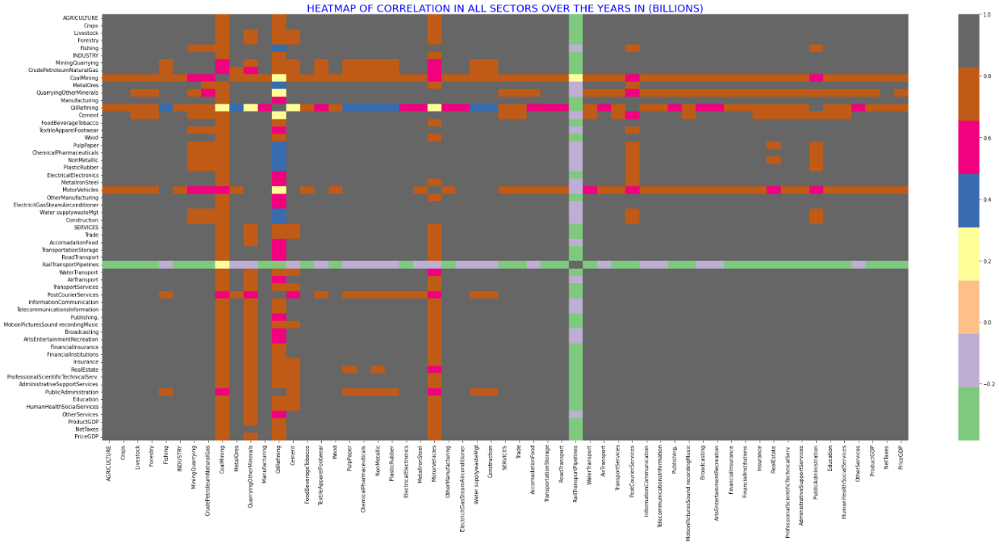

İn the above figure (figure 1a), there is a strong negative correlation between rail transport & pipelines against other sectors, which may imply explictitly that the Rail transport & pipelines is behave quite opposite to other sectors of the economy except for a slight positive correlation with Oil Refining . There is a strong positive correlation between Oil Refining and Mining & Quarrying have a strong positive correlation between them over the years. There seems to be a positive correlation amongst other sectors with correlations tending toward 1 while there are many correlations at 1, it may not necessarily imply that an increase in any of such sector imply a positive output in another or vice-versa.

Figure 1b: A statistical summary plot of output in various sectors through the years in billions

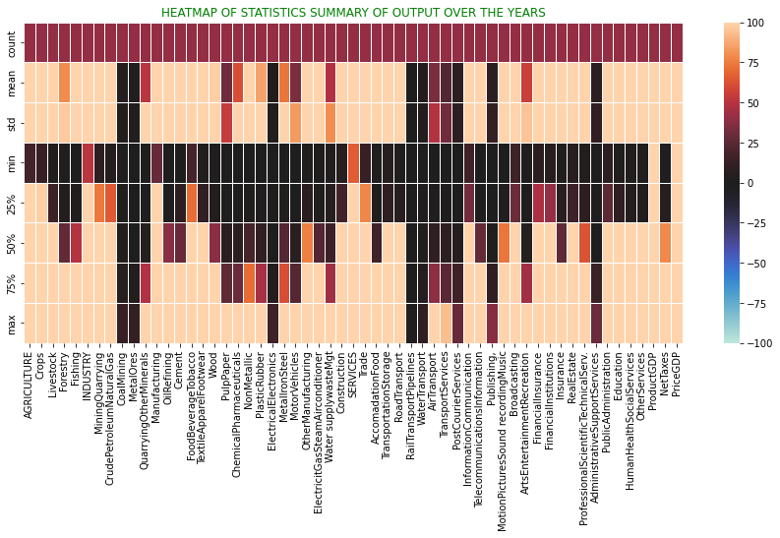

The figure 1b above plots Minimum, Mean, Standard Deviation, 25th, 50th and 75th percentiles of total outputs in various sectors in billions. While the mean and maximum statistics of total output in most sectors are seen to be grossing above 50billion except for Coal Mining, Metal Ores, Electrical Electronics, Rail Transport & Pipelines, Post & Courier Services, Publishing, And Administration Support Services. A closer look willl also show that Manufacturing, Food Beverage & Tobacco, İndustry, Services, İnformation & Telecommunications showed a positive statistical summary over the years making them the most triving sector of the economy irrespective of challenges or outcomes in political, economic or natural stability or disaster.

Figure 1c: A heatmap plot of percetage change in various sectors through the years

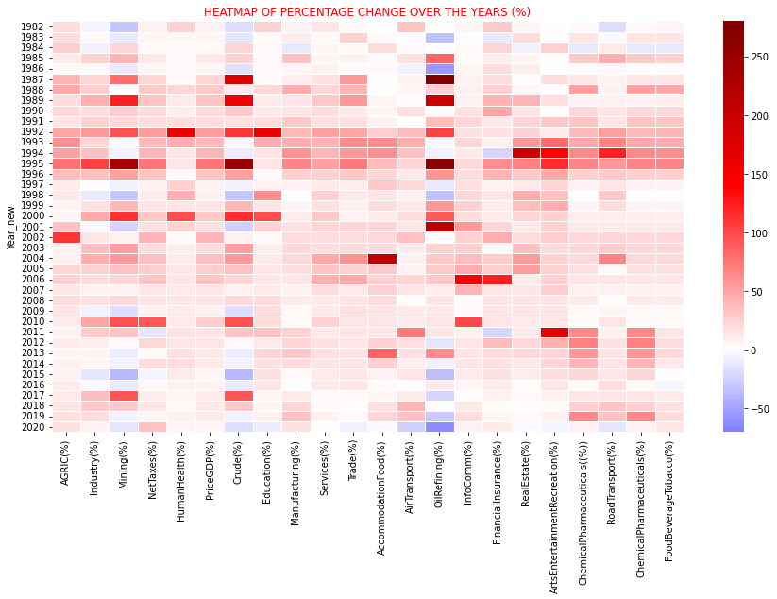The above plot shows percentage change in various sectors over the years, the whitter the shade, the closer the value of percentage change is closer to zero with blue being a negative change and the darker the shade of blue, the more negative the percentage change within the sector in that year while the darker the red, the higher the percentage of positive change. İt’s safe to say here that if we observe through the years, no year has had more negative change than the year 2020. Except a few industries that managed to return positive percentage change from the previous years, the year 2020 was the highest low hit in terms of change over the years with oil refining being the worst and its been 2014 after bouncing back in the previous year of a negative change. This is definitely the yaer that covid 19 impact was felt more severly on the economy. İts actually not suprising here that the three most colorful sectors here are Oil Refining , Crude Petroleum and Natural Gas and Mining & Quarrying they exhibit high volatility in percentage change over the years in review going from a negative change to a peak positive change the next year. Between 2002 to 2008, all sectors were returning a positive percentage change which means the economy was breaking new highs during those years which could have been from 1999 to 2008 if not for a negative percentage change from Crude Petroleum and Natural Gas and Mining & Quarrying. So, it’s safe to say that those years were the best years for our economy.

Figure 1d: Statistical summary of percentage of change through the years in various secto
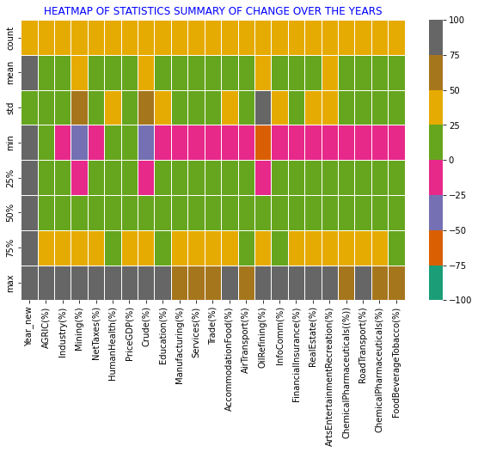The figure 1d above shows Minimum, Mean, Standard Deviation, 25th, 50th and 75th percentiles of percentage change in various sectors over the years in billions. The summary of statistics shown indicates that while most Economic Sectors have in one time or the other expreienced a negative percentage change as evidenced by minimum percentage cahnge, the Agricultural, Heathcare & Social Services Sectors have never had a negative percantage return within these years under review.

Figure 2a: Linegraph of percentage of change through the years in various sectors
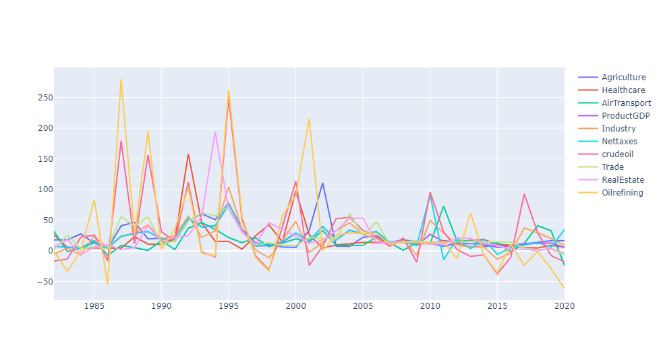

The line graph (figures 2a) above and (fogure 2b) below clearly illustrates the dipping of percentage change of all sectors of the economy over the years and especiall, the oil refining as well as Crude Petroleum and Natural Gas sector seems to have more volatility than other sectors. The oil refining sector accounts for most of the peaks and troughs visible on the line chart and closely followed by Crude Petroleum and Natural Gas.

Figure 2b: Linegraph of percentage of change through the years in various sectors

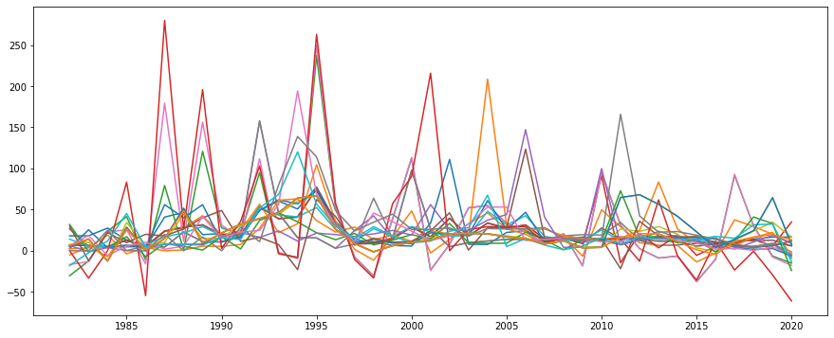It could also be seen that a range in percentage of changes in all sectors are between -61% to 16.7 % in 2020 which clearly shows why all the graph lines are clustered around the zero and negative axis. This clustering has been evident since about 2016 with almost all the percentage change line clustered around the zero line. Its however unfortunate that when it seemed that the various sectors were trying to pick up momentum from a downward state to upward turn, the pandemic struck, further bringing most sectors into negative change or reversal of upward movement with the oil sector as the most hit, shown above by the red line in the graph.

Figure 2c : A correlation plot of percentage change through the years in various sectors

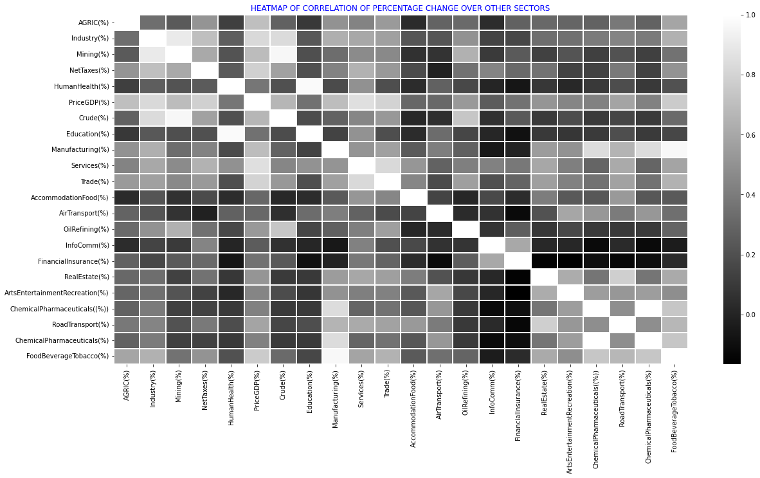The above chart is a correlation of percentage of change amongst various economic sectors against each other over the years. The darker the shade, the more negative the correlation between the sectors in terms of percentage change whle the lighter the shade, the more positiive a correlation it is terms of pertange change between sector, while the shades in between dark and ash may indicate that correletion does not exist in terms of percentage change between sectors. The white shades shows a perfect positive correlation which does not exist because its a sector of the economy against itself.

Figure 2d : Regression plot of output through the years in various sectors

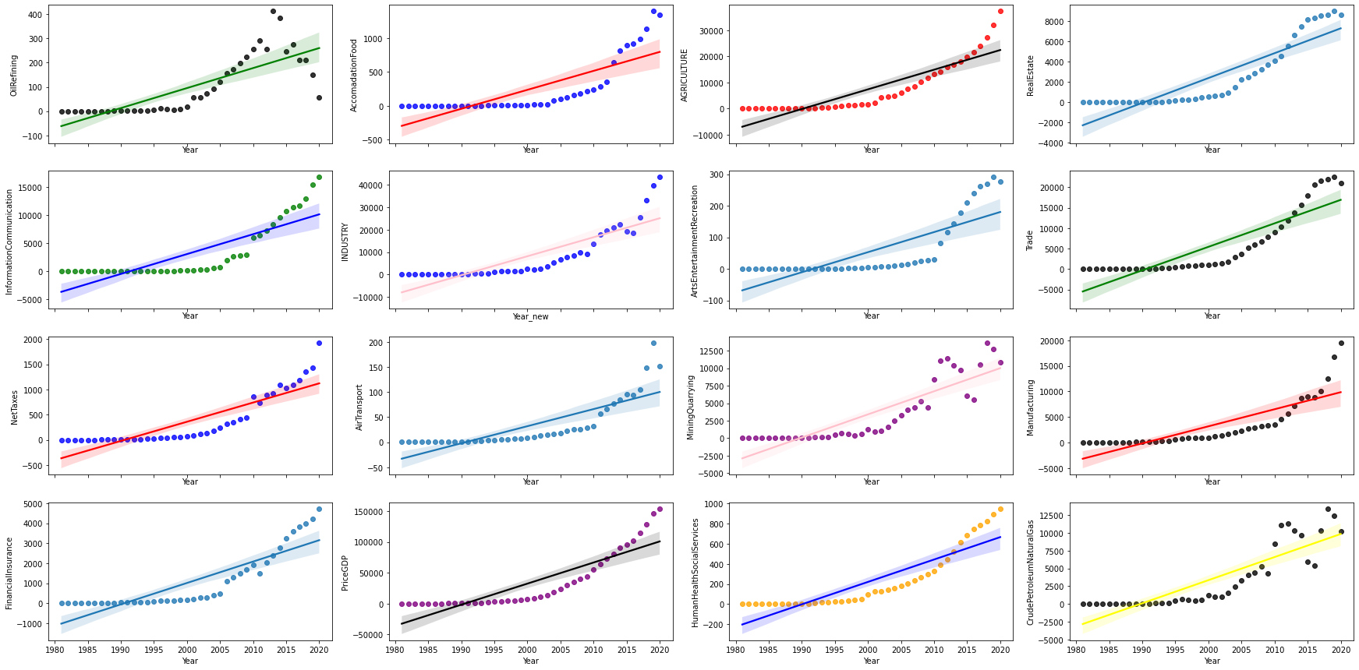

Figure 2e: Regression plot of percentage change through the years in various sectors

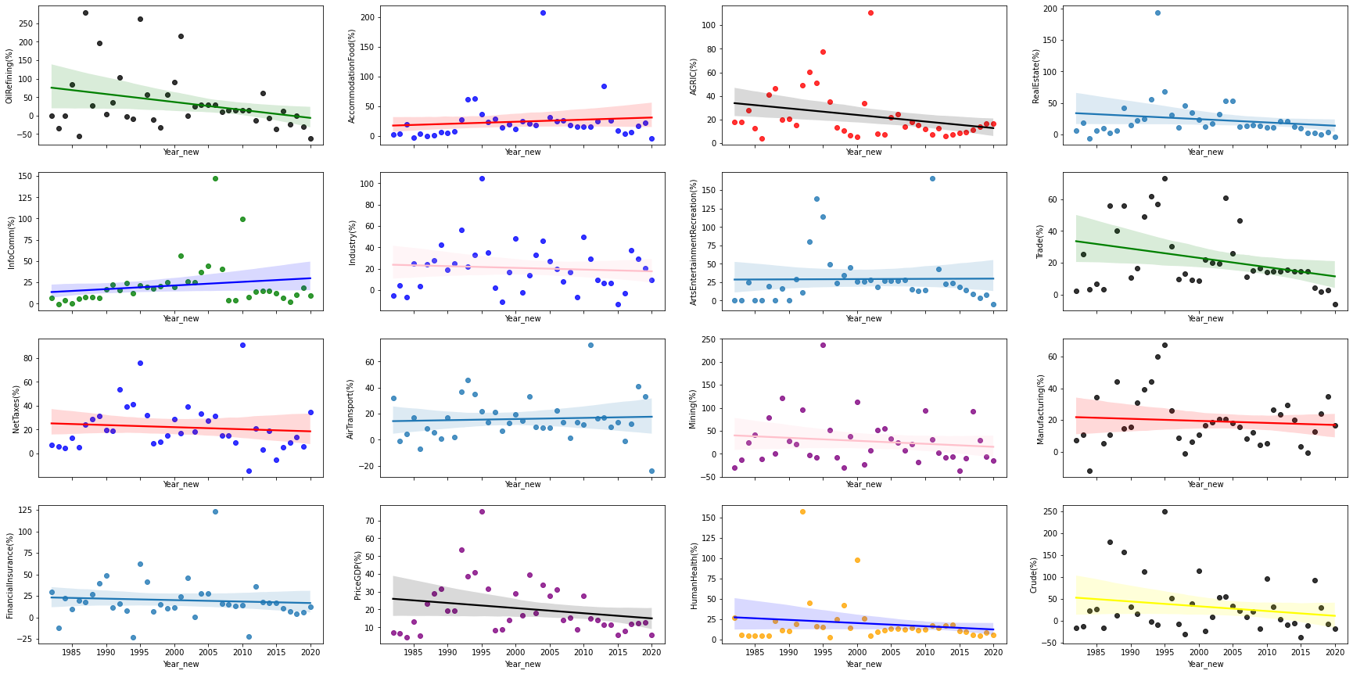

First row, left to right: Oil Refining, Accommodation And Food Services, Agriculture, Real Estate

Second row, left to right: Information & communication, Industry, Arts Entertainment Recreation, Trade

Third row, from left to right: Net Taxes , Air Transport, Mininig & Quarrying, Manufacturing

Last row, left to right: Financial & Insurance , GDP at Current Basic Prices, Human Health & Social Services, Crude Petroleum and Natural Gas.

The above chart (figure 2d) is a regression plot of total output in 16 sectors of the economy over the years while in (figure 2e) its a regression plot of percentage change over the years in same sectors as the top plot (figure 2d) is a replica of .plot (2e) but both differ in that they are abosulte value regression and percentage change regression repectively.

As can be seen above in (figure 2d), the regression plot of absolute output values in all of the economic sector have a positive correlation with time which may lead one to say that over time, the economic sectors have been thriving better but a closer look at (figure 2e), which is a regression of percentage of change over the years will show clearly that most sectors of have rather a negative correlation with time. This means that time does not impact on the percentage of change in various sectors except for Accommodation & Food Services, Information & communication and Transport that showed postive correlation with time, meaning that as time went by, the percentage change increased in those sectors and finacial & insurance sector remaining neutral over time. Meanwhile, in other sectors of the economy, as time went by, percentage change decreased over the years
The scatterplot on oil refining is negatively correlated to the years axis showing as time passes the amount of crude oil refined decreases. This is due to the poor state of the three major refineries in the country resulting in more importation of refined crude.
4.2 INVESTMENT AND TRADE OPPORTUNITIES
Figure 2f: a bar chart of trade from year 2000 to 2020
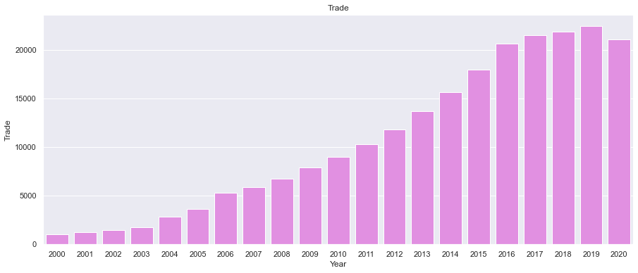

From 2000 to 2020, the trend in trade and investment opportunities in Nigeria is depicted in the image above. Up to 2019, Nigeria's trade and investment opportunities increased before the Covid-19 epidemic. When Nigeria imposed a complete shutdown in 2020, the commerce fell precipitously. Due to the effects of the pandemic and in an effort to stop its spread, Nigeria's trade and business partners, who are mostly in Europe, the United States, and China, closed their economies and international borders. This has a significant impact on Nigeria's overall economy, reserve, and national revenue earnings. In addition, businesses that depended on imported goods for their operations had to close because of a lack of raw materials and rising manufacturing costs.

4.3 Global demand for commodity
Figure 2g: A line chart of crude oil output from yaer 2000 to 2020
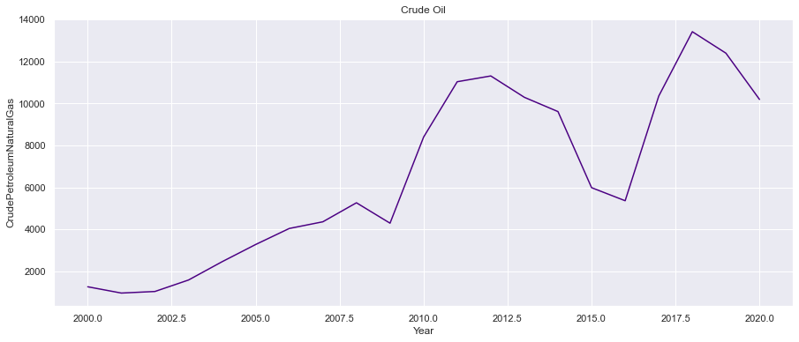
The image above depicts the trend in commodity demand around the world. The image depicts a sharp fall in global commodity demand, which had an impact on the price of crude oil on the world market. Due to the fact that a significant percentage of Nigeria's income comes from the export of crude oil, the price of crude oil is the most accurate predictor of the country's overall revenue. Due to the global economic slowdown in 2020, Nigeria's oil price fell, and sales of crude oil also saw a decline in revenue. Due to these factors, the Nigerian government had limited financial assistance and earnings to maintain the economy, particularly the health sector, which was in disrepair. Additionally, the various governments found it difficult to pay their employees' salaries, which added to the economic difficulty, poverty, and misery in society. The drop in oil demand and oil prices also had a negative impact on the volume and value of Nigeria's net exports, which account for 90% of its exports. In fact, the pandemic-related sharp decrease in oil prices forced the Nigerian government to reduce its budgeted spending. Finally, the country's budget deficit deteriorated as a result of the drop in crude oil export prices from March to April, forcing the Nigerian government to look outside for loans in order to stop the current economic catastrophe.

4.4 Digital Economy
Figure 2h: a line graph of telecommunications and information from 2000 to 2020
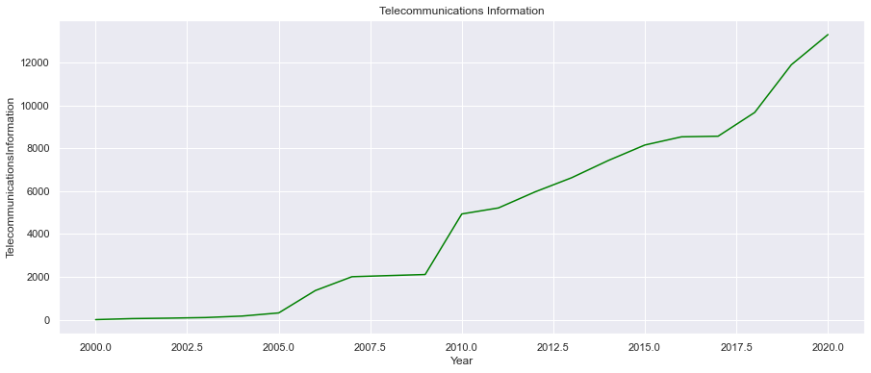
The analysis of Nigeria's digital economy trajectory both before and after the COVID-19 epidemic is shown in the image above. It demonstrates a rise in the percentage of people who use the internet to make mobile calls, pay bills, and send virtual currency. However, very few universities or schools provided an entire academic program online during the COVID-19 pandemic. Instead of adopting the "working from home model," many businesses operated under the tradition of going into the office and doing your work. The coronavirus outbreak posed a problem for Nigeria's corporate environment. Nigeria's markets, enterprises, and industries have negative effects on their operations due to the country's digital infrastructure. As a result of Nigeria's weak and undeveloped digital economy, the only digital services offered at the COVID-19 were telephone, internet, and bank transfer services.

4.5 Supply chain and Manufacturing
Figure 2i: A bar graph of other manufacturing from year 2000 to 2020
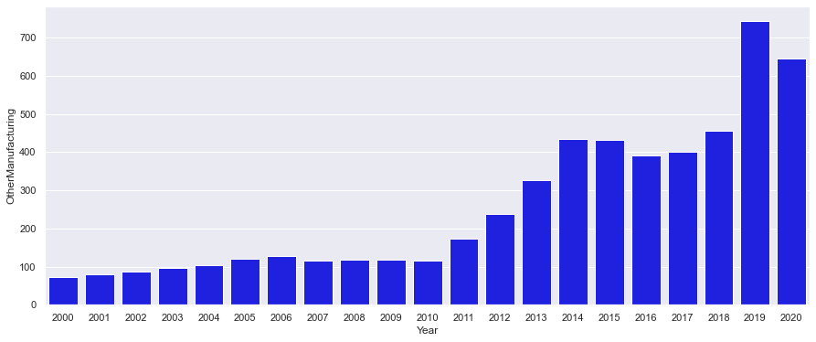
The picture above shows the economic trends in manufacturing industries measured by the Purchasing Managers Index (PMI). Prior to the Covid-19 pandemic's onset, the manufacturing industries can be seen to be on the rise in the image. The border closure and restrictions on travel during the outbreak in 2020 indicated a drop in exports and manufacturing industry activity. This was due to the lockdown restriction, which stopped workers from working, lenders from issuing new loans, and customers from purchasing things at the time, all of which impacted the real sector, particularly supply chains. Countries all over the world restricted their borders to non-essential commerce, disrupting global supply networks for exports. Additionally, the closure of factories and national borders by importers and exporters caused supply shocks in the global supply chain. These closures had a negative impact on Nigeria's export commerce and consequently, her economy. Imported products include food staples like rice, as well as finished products, medications, and spare components.

4.6 Social welfare infrastruction
Figure 2j: a bar graph of insurance sector from year 2000 to 2020
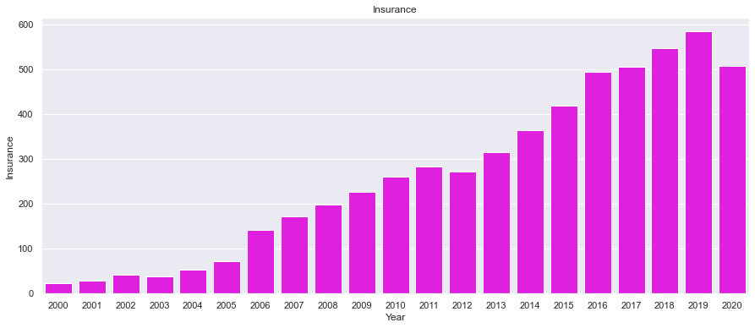

The picture above shows the analysis of Nigeria’s social welfare infrastructure prior to the COVID-19 pandemic. It demonstrates that from 2012 to 2019, the social insurance programs' sufficiency as a share of recipient households' overall wellbeing in Nigeria rose. A social safety net existed in Nigeria prior to the COVID-19 pandemic, as seen by the increase. However, in practice, these protections were nonexistent and ineffective during the COVID-19 pandemic in 2020.

4.7 Inflation
Figure 2k: A bar graph showing output from accomodation & food sector.
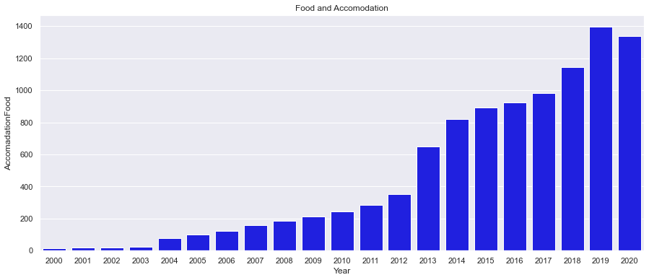

The analysis above shows an upward trend prior to the outbreak up until 2020 when lockdown was efforced by the Nigeria government to curtail the spread of Covid-19. Nigeria, which has the highest amount of extremely poor people in the world according to the United Nations statistical report, was significantly affected by the COVID pandemic. More specifically, as inflation, unemployment, and poverty rates grew, the COVID pandemic had a significant negative impact on nigeria's level of poverty and economic suffering. Additionally, the global economic crisis had a detrimental effect on Nigeria's earnings from overseas as remittances from her citizens, who supported numerous households and families, sharply decreased. As trade borders were blocked and interstate travel was prohibited as a result of the lockdown limitation, the price of consumer products increased and the flow of goods across the nation was hindered.

4.8 The Aviation Sector
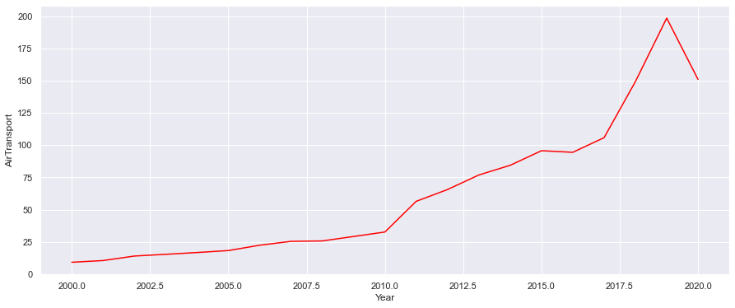
The trend of the aviation section is depicted in the graph above. The graphic indicates that the section saw a dramatic downward movement in 2020 during the epidemic and an apparent constant upward movement prior to the outbreak. This was due to the industry's struggles to recover from unheard-of losses caused by numerous travel bans that only allowed for absolutely necessary travel. To get out of their problems, certain airlines requested bailout money for sustainability, including UK airlines to the tune of 7 billion euros. According to Morgan (2020), the AMCON (Asset Management Corporation of Nigeria) pleaded for bailout funding for Nigerian airlines to avoid a closure of the aviation industry. However, even with the bailout monies, the pandemic's effects were seen in the line cahrt above.

CHAPTER FIVE
SUMMARY OF FINDINGS, CONCLUSION AND RECOMMENDATION
5.1 Summary of Findings
The purpose of this study was to explore the global economic impact of Covid-19: Nigeria in perspective. The following are a brief summary of findings. The Covid-19 pandemic epidemic had a big influence on the supply chain. In particular, the sharp decline in economic activity has had a substantial influence on social policy as well as the social and economic well-being of residents. (Ozili, 2020a). The lockout caused difficulties in the manufacturing sector due to labor shortages, problems with supply chains and transportation, and falling demand. (Baldwin and di Mauro, 2020). The findings showed that the adequacy of social insurance programs, as a percentage of total welfare of beneficiary households in Nigeria, increased from 2012 to 2019. In addition, the sharp decline in economic activity had a substantial influence on social policy as well as the social and economic well-being of residents. (Ozili, 2020a). Because the people's livelihoods depend on daily salaries, Barnett-Howell and Mobarak (2020) noted, lockout costs in developing nations were higher because disrupting economic activity posed a significant risk to public health. The findings revealed a significant decline in global demand for commodity which affected the price of crude oil in the global market. These COVID-19 pandemic spillovers caused a decrease in commodity demand and restricted economic activity when the physical distance rules were put into place. (Ozili, 2020b). Hence, the study accepted the hypothesis that the covid-19 pandemic negatively impacted on the Nigerian economy.

The Nigerian economy recorded a surge in 2021 after the fall it experienced in 2020. Considering the effects of the pandemic and the economy records, the GDP having consecutive positive growth in all three quarters of 2021; 0.51%, 5.01%, and 4.03%.
Likewise, the year saw inflation rates declining for eight months, from March to November although an increase was recorded in December. This increase in inflation has continued unabated and at the time of this study Nigeria has recording an all time high inflation rate of 20%.
These economic indicators show improvement from a Covid-ravished economy. However, economic realities and the statistics don’t align and it appears Nigeria is still struggling from the impact of coronavirus. Socio-economic statistics are improving but socio-economic realities are moving in the opposite direction.
After the economic crisis experienced in 2020, the economy gradually picked up steam as it raised its nose over the immeasurably deep gulf it fell into. This was pioneered by increased government spending as the GDP surged up in 2021 to positive figures and it is projected that the economy will grow by 4.2% in 2022.
The inflation rate in 2021 started on a high note at 16.47%, increasing to 18.17% in March. After that, there was a steady decline in the inflation rate for eight months ending in November at 15.4%. It, however, picked up in December, closing the year at 15.63%.
On the flip side where economic realities lay, research has shown how food prices have risen exponentially.
Based on the insights of the data and its resultant output, the pandemic affected many enterprises, which led to their closure and the laying off of employees. By the end of 2020, the country recorded an all-time high in unemployment rates. The country’s unemployment rate increased from 27.11% in the second quarter of 2020 to 33.28% by the end of the year. The country started the year with an unemployment rate of 33.28%. The situation has pushed many into poverty. Nigeria moved from having 0.1% of its population going into poverty every second in 2020 to 3.3% in 2021.
The country’s population that is living below the poverty line moved from 39% in 2020 to 41% in 2021. Moreso, it is expected that this will continue to increase, pushing 11 million more people into poverty at the end 2022.
Although the country’s GDP shows remarkable economic progress attributed to increased spending on goods and services, it has limitations such as not taking into account some economic statistics. The GDP does not reflect the living standards of the people and the income inequality inherent in the economy. There have been arguments that GDP should not be the sole determinant of economic assessments and policies for its failure to capture significant aspects of a country’s realities.
Off course, socio economic data shows that Nigeria is progressing and recovering from the devastation of the coronavirus pandemic, but that is not what Nigerians are experiencing and data on unemployment and people living below the poverty line agree with the people’s experiences. There is a need for purposeful reforms and policies to bridge the gap and ensure balanced economic performance.

5.2 Conclusion
Based on the evidence at hand, this study comes to the conclusion that the COVID-19-induced lockdown has severely restricted economic activity and, consequently, the cyclical movement of revenue in Nigeria. Additionally, Nigeria experienced an economic recession as a result of perceived declines in economic activity and the circular flow of revenue. This study has significantly added to our understanding of data and management sciences. The implications of the Covid-19 pandemic on Nigeria's economy are identified, as well as potential coping mechanisms, in this study. In general, the Covid-19 pandemic affects Nigeria's economy in social, religious, political, and economic ways. The Covid-19 pandemic has specifically caused a substantial fall in worker pay, job losses, food insecurity, business failures, school closures, a dramatic decline in oil earnings, a rise in death rates, and economic uncertainty in Nigeria.

5.3 Recommendations
- To diversify the economy and lessen Nigeria's reliance on revenue from crude oil exports, policymakers should enact economic reforms.
- Against strengthen Nigeria's national health system's resistance to the spread of contagious illnesses, officials should spend money on the country's healthcare infrastructure.
- Policymakers should also use legislation to establish a strong social safety net for all residents, especially for unemployed people and low-income households.
- Lastly, the government has to concentrate on reestablishing institutions and give organizations like NCDC and NAFDAC more attention

Figure 3: Picture of the analysis on jupyter workbook
REFERENCES

- The raw code of this work can be asssessed on github through https://github.com/ibe-abu-chi/python_EDA/blob/master/capstone%20analysis.ipynb

- Andam, Kwaw S.; Edeh, Hyacinth; Oboh, Victor; Pauw, Karl; and Thurlow, James. 2020. Estimating the economic costs of COVID-19 in Nigeria. NSSP Working Paper 63. Washington, DC: International Food Policy Research Institute (IFPRI). https://doi.org/10.2499/p15738coll2.133846

- Economic consequences of the COVID-19 Pandemic(2020) https://www.copenhageneconomics.com/dyn/resources/Publication/publicationPDF/0/530/1585835646/copenhagen-economics_economic-consequences-covid-19.pdfGoogle Scholar, Crutsinger, 2020

- How COVID-19 Is Impacting the Flow of People, Information, Goods, and Money (2020) (Online) https://medium.com/@efeng/how-COVID-19-is-impacting-the-flow-of-people-information-goods-and-money-9719f80e9f63Google Scholar

- The Great lockdown: worst economic downturn since the great depression (2020) https://blogs.imf.org/2020/04/14/the-great-lockdown-worst-economic-downturn-since-the-great-depression/Google Scholar

- H.E. Inegbedion, COVID-19 lockdown: implication for food security J. Agribusiness Dev. Emerg. Econom. (2020) Google Scholar

- Impacts of COVID-19 on inclusive economic growth in middle-income countries K4D Helpdesk Report 811. Institute of Development Studies, Brighton, UK (2020) Google Scholar

- M. Maryla, M. Aaditya, V. Dominique, The Potential Impact of COVID-19 on GDP and Trade: A Preliminary Assessment. Policy Research Working Paper; No. 9211. World Bank, Washington, DC (2020) (Online). Available at https://openknowledge.worldbank.org/handle/10986/33605 License Google Scholar

- P.K. Ozili, COVID-19 Pandemic and Economic Crisis: The Nigerian Experience and Structural Causes (April 2, 2020 Available at SSRN: https://ssrn.com/abstract=3567419 Google Scholar

- P. Ozili, COVID-19 in Africa: socio-economic impact, policy response and opportunities Int. J. Sociol. Soc. Policy (2020) Vol. ahead-of-print No. ahead-of-print Google Scholar

- R. Shretta, The Economic Impact of COVID-19. Nuffield Department of Medicine, University of Oxford website (2020) Retrieved from Centre for Tropical Medicine and Global Health https://www.tropicalmedicine.ox.ac.uk/news/the-economic-impact-of-COVID-19 Google Scholar

- R. Baldwin, B.W. di Mauro (Eds.), Economics in the Time of COVID-19 (2020) Baldwin and Tomiura, 2020 R. Baldwin, E. Tomiura

- Thinking ahead about the trade impact of COVID-19 R. Baldwin, B.W. di Mauro (Eds.), Economics in the Time of COVID-192 (2020)

- Nnadi, C.F. and Nweze, A.U. (2018). Fundamentals of Management Research: Concept and Analysis 1 st edition printed an Bound in Enugu Nigeria by JTC Publishers.

- P.K. Ozili. COVID-19 Pandemic and Economic Crisis: The Nigerian Experience and Structural Causes (April 2, 2020)

- R. Shretta, The Economic Impact of COVID-19 Nuffield Department of Medicine, University of Oxford website (2020)

- M. Teachout, C. Zipfel, The economic impact of COVID-19 lockdowns in sub-Saharan Africa Int. Growth Centre Policy Brief (2020) Google Scholar

- J. Thurlow, COVID-19 Lockdowns Are Imposing Substantial Economic Costs on Countries in Africa (2020) Available at https://www.ifpri.org/blog/COVID-19-lockdowns-are-imposing-substantial-economic-costs-countries-africa. Google Scholar
- J.F. Ade Ajayi, Nigeria - Economy | Britannica

